Project Report

**Module:** 5CS045 Full Stack Development

**Student Name:** Noor Jamal Ali Abdulgasem

**Student ID:** 2528160

**Project Title:** Recipe Manager

**Submission Date:** 05/12/2025

**GitHub Repository:** <https://github.com/noorabed7/recipe-manager.git>

Table of Contents

1. Introduction 3

2. Technologies Used 3

3. System Architecture 4

3.1 Architecture Overview 4

3.2 Application Flow 5

4. Database Design 6

4.1 Entity Relationship Diagram 6

4.2 Table Structure 7

5. Features 8

5.1 Use Case Diagram 8

5.2 CRUD Operations 8

5.3 Multi-Criteria Search 9

5.4 Ajax Autocomplete 11

6. Security Implementation 12

6.1 SQL Injection Protection 12

6.3 CSRF (Cross-Site Request Forgery) Protection 12

6.4 Session Security 13

6.5 Security Summary 13

7. Screenshots 14

7.1 Home Page (Recipe Grid) 14

7.2 Add Recipe Form 14

7.3 View Recipe Details 15

7.4 Edit Recipe Form 16

7.5 Delete Confirmation 16

7.6 Search Functionality 17

7.7 Autocomplete in Action 18

8. Conclusion 19

Project Files 20

## 1. Introduction

The Recipe Manager is a full-stack web application designed to help users manage their cooking recipes. The application provides a complete CRUD (Create, Read, Update, Delete) system for recipes, along with advanced search capabilities and real-time autocomplete functionality.

This project demonstrates the implementation of a database-driven web application with proper security measures, user-friendly interface, and modern web development practices.

## 2. Technologies Used

|  |  |
| --- | --- |
| Technology | Purpose |
| PHP | Server-side scripting and business logic |
| MySQL | Relational database management |
| JavaScript | Client-side interactivity and Ajax requests |
| HTML5 | Page structure and semantic markup |
| CSS3 | Styling and responsive design |

## 3. System Architecture

The application follows a traditional three-tier architecture with clear separation between the presentation layer, application logic, and data storage.

### 3.1 Architecture Overview

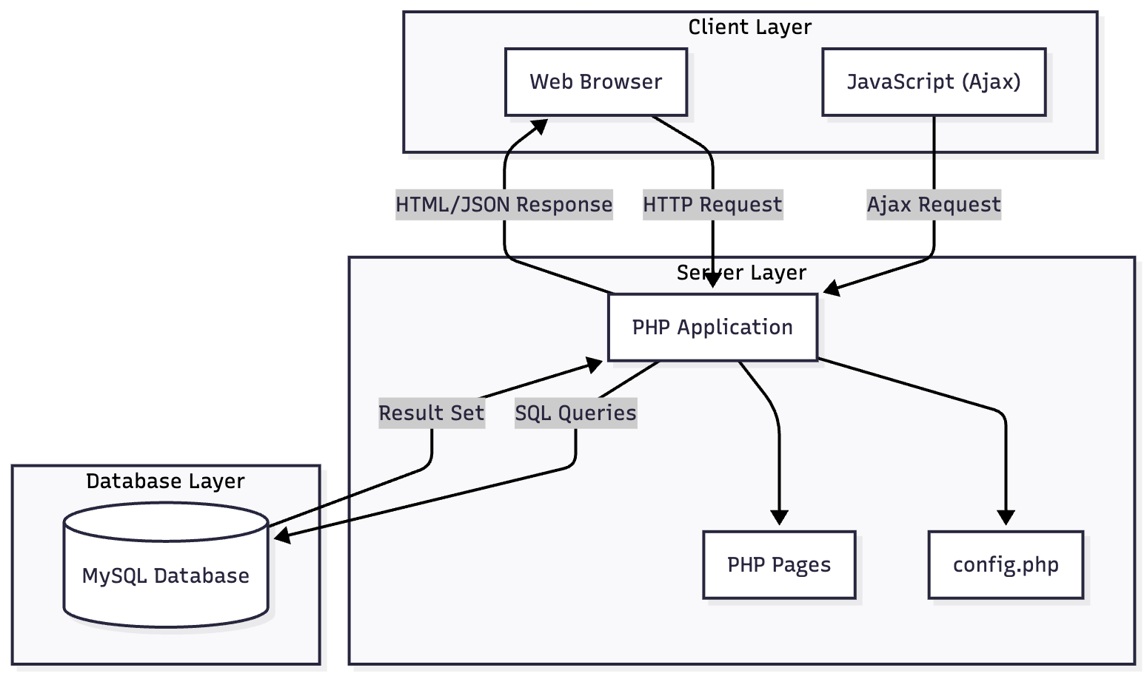

### 3.2 Application Flow

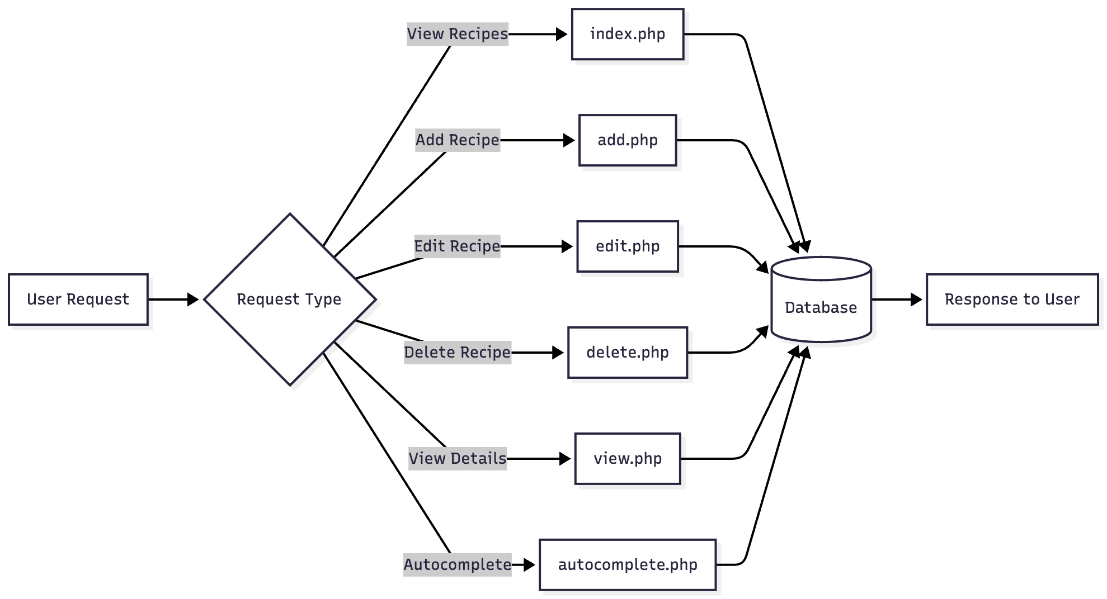

## 4. Database Design

### 4.1 Entity Relationship Diagram

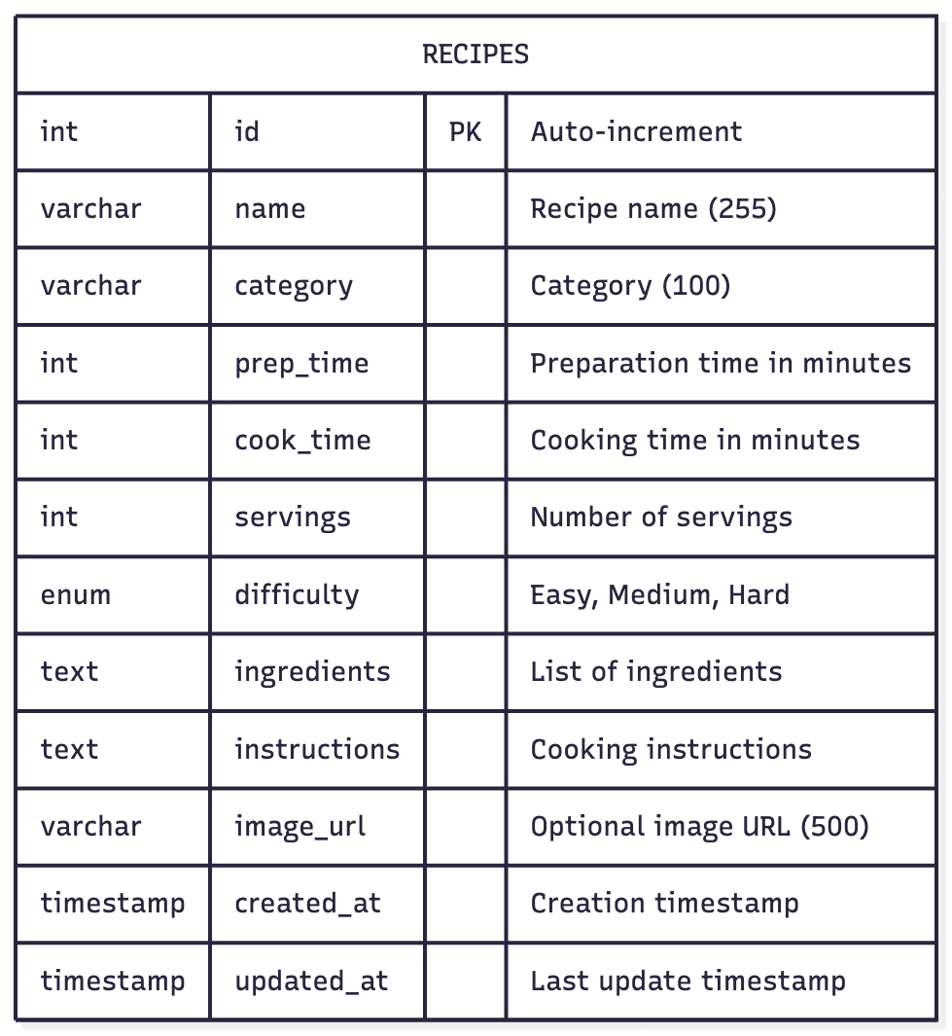

### 4.2 Table Structure

|  |  |  |  |
| --- | --- | --- | --- |
| Column | Data Type | Constraints | Description |
| id | INT | PRIMARY KEY, AUTO_INCREMENT | Unique identifier |
| name | VARCHAR(255) | NOT NULL | Recipe name |
| category | VARCHAR(100) | NOT NULL | Recipe category |
| prep_time | INT | NOT NULL | Preparation time (minutes) |
| cook_time | INT | NOT NULL | Cooking time (minutes) |
| servings | INT | NOT NULL | Number of servings |
| difficulty | ENUM | DEFAULT 'Medium' | Easy, Medium, or Hard |
| ingredients | TEXT | NOT NULL | List of ingredients |
| instructions | TEXT | NOT NULL | Step-by-step instructions |
| image_url | VARCHAR(500) | NULL | Optional image URL |
| created_at | TIMESTAMP | DEFAULT CURRENT_TIMESTAMP | Record creation time |
| updated_at | TIMESTAMP | ON UPDATE CURRENT_TIMESTAMP | Last modification time |

## 5. Features

### 5.1 Use Case Diagram

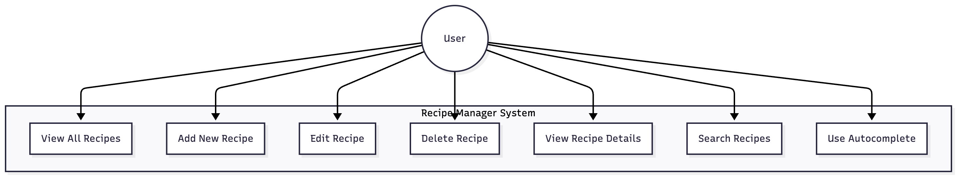

### 5.2 CRUD Operations

#### Create (Add Recipe)

Users can add new recipes by filling out a form with the following fields:

* Recipe name
* Category
* Preparation time
* Cooking time
* Number of servings
* Difficulty level (Easy, Medium, Hard)
* Ingredients (one per line)
* Instructions (step by step)

**Implementation:** add.php

#### Read (View Recipes)

* **List View:** The home page displays all recipes in a responsive grid layout with key information (name, category, times, difficulty)
* **Detail View:** Individual recipe pages show complete information including ingredients and step-by-step instructions

**Implementation:** index.php (list), view.php (details)

#### Update (Edit Recipe)

Users can modify any existing recipe. The edit form is pre-populated with current values for easy editing.

**Implementation:** edit.php

#### Delete (Remove Recipe)

Users can delete recipes with a confirmation step to prevent accidental deletion.

**Implementation:** delete.php

### 5.3 Multi-Criteria Search

The search functionality allows users to filter recipes using multiple criteria simultaneously:

|  |  |
| --- | --- |
| Criteria | Description |
| Recipe Name | Partial text match search |
| Category | Exact match filter (dropdown) |
| Max Total Time | Filter by combined prep + cook time |

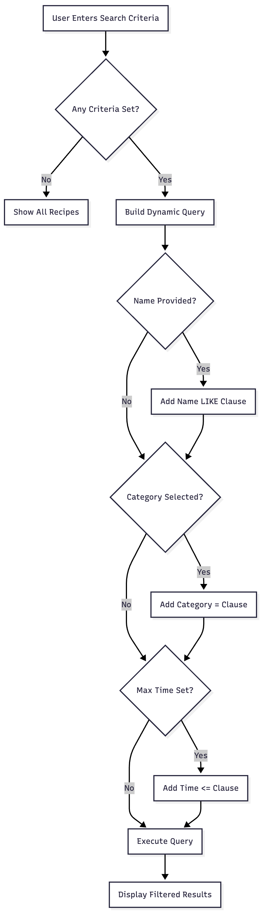

### 5.4 Ajax Autocomplete

Real-time search suggestions appear as the user types in the search field:

* Triggers after 2+ characters are typed
* Uses debouncing (300ms delay) to prevent excessive requests
* Displays matching recipe names with their categories
* Clicking a suggestion populates the search field

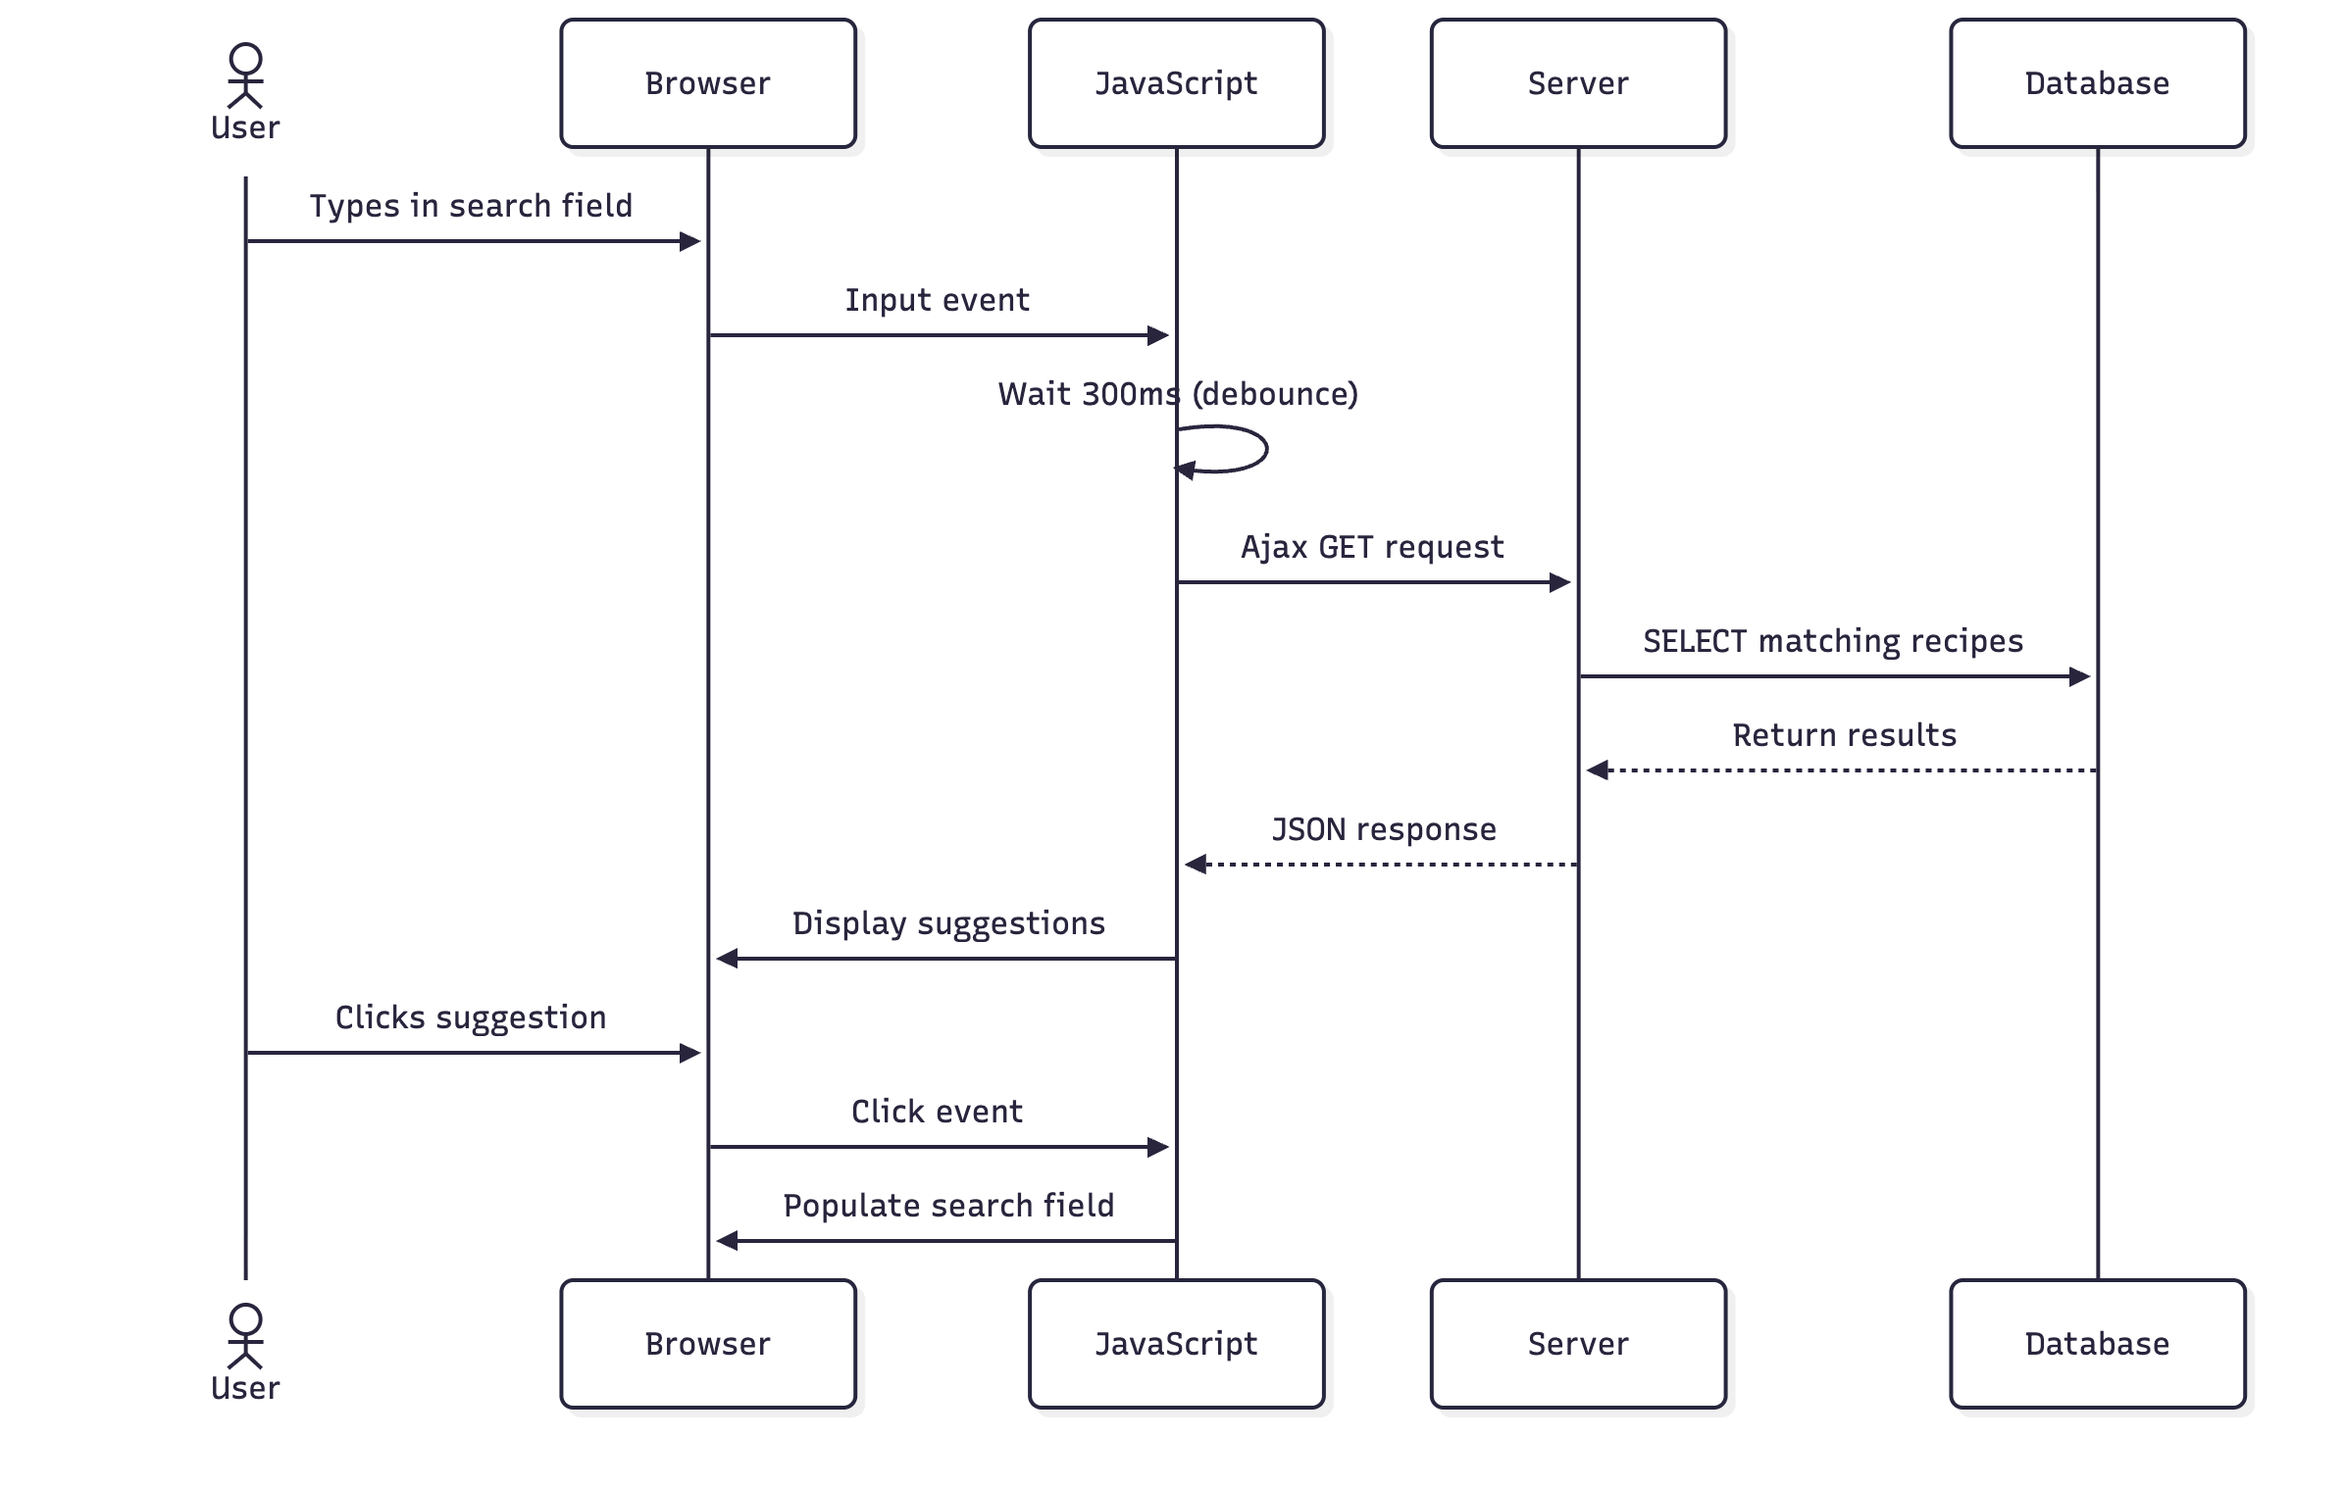

## 6. Security Implementation

The application implements multiple layers of security to protect against common web vulnerabilities.

### 6.1 SQL Injection Protection

All database queries use **prepared statements** with parameter binding to prevent SQL injection attacks.

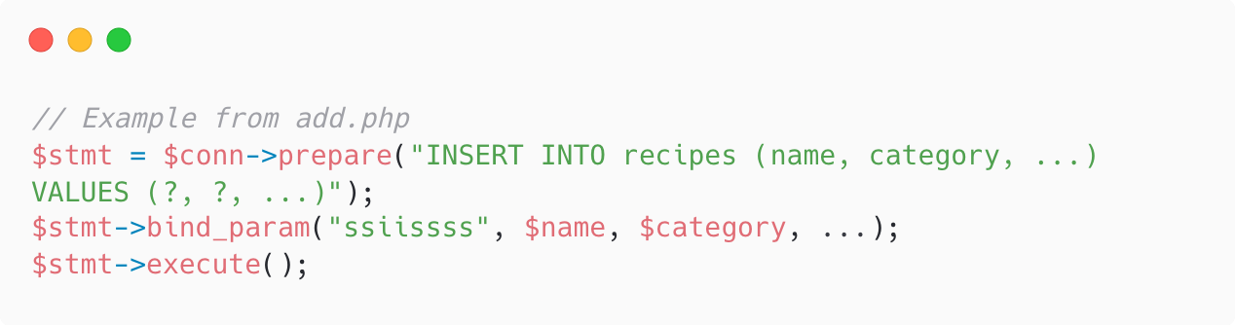6.2 XSS (Cross-Site Scripting) Protection

All user-generated content is escaped before output using the *htmlspecialchars()* function, wrapped in a helper function *h().*

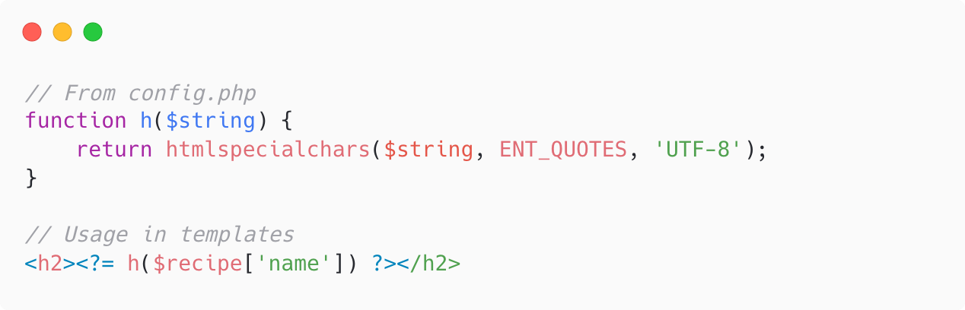

### 6.3 CSRF (Cross-Site Request Forgery) Protection

All forms include a CSRF token that is validated on submission:

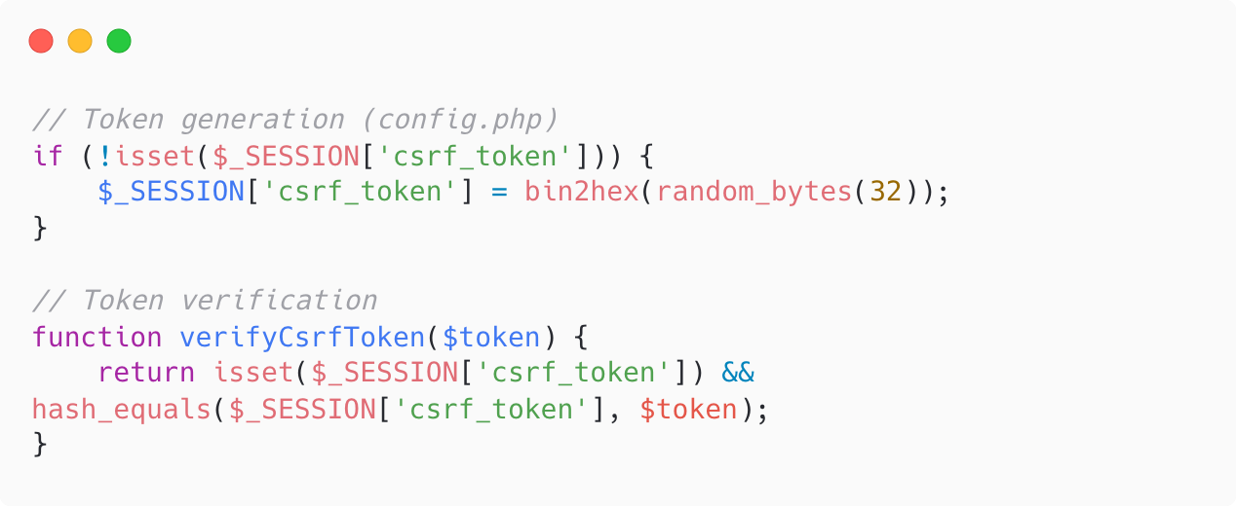

### 6.4 Session Security

Sessions are configured with security best practices:

* HTTP-only cookies (prevents JavaScript access)
* Cookie-only session IDs (prevents session fixation)

### 6.5 Security Summary

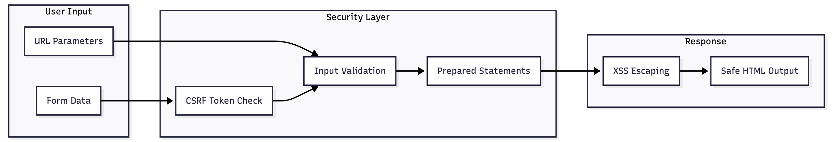

## 7. Screenshots

### 7.1 Home Page (Recipe Grid)

Screenshot showing the main page with recipe cards displayed in a grid layout

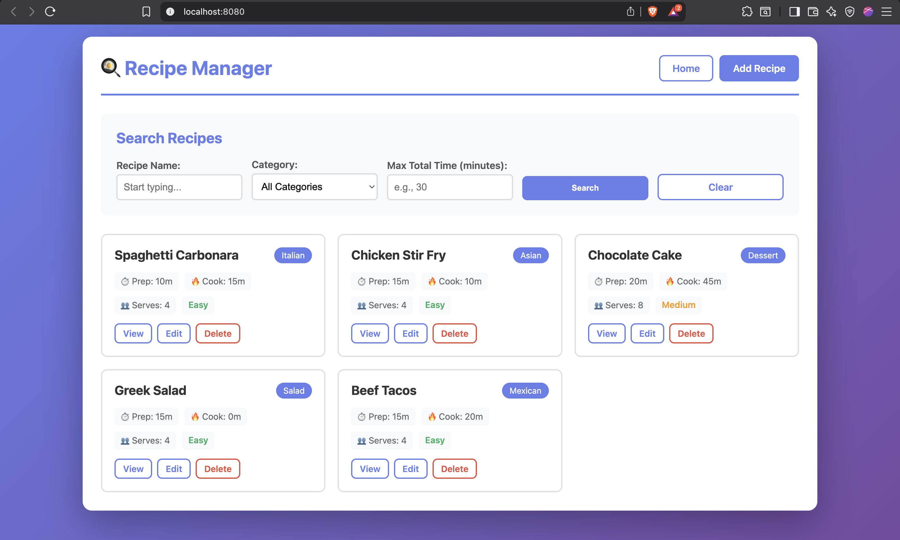

### 7.2 Add Recipe Form

Screenshot showing the form for adding a new recipe with all input fields

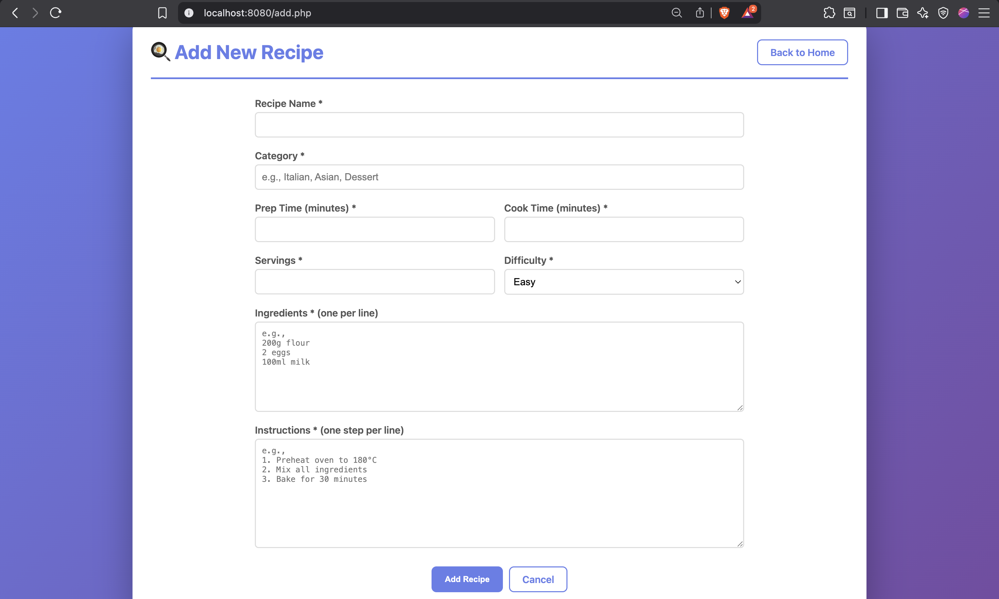

### 7.3 View Recipe Details

Screenshot showing the detailed view of a single recipe with ingredients and instructions

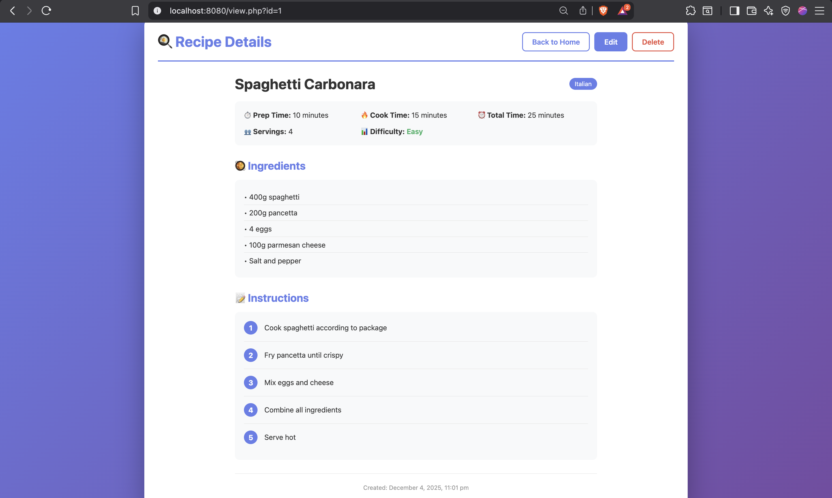

### 7.4 Edit Recipe Form

Screenshot showing the edit form pre-populated with existing recipe data

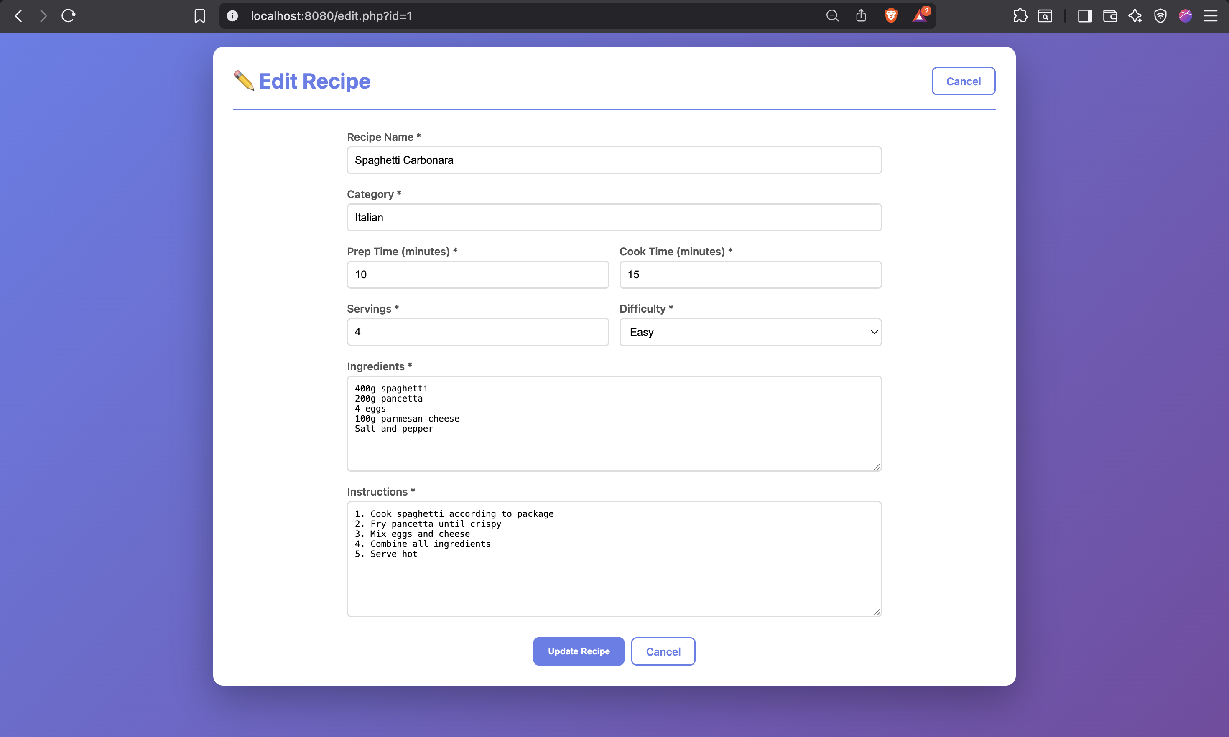

### 7.5 Delete Confirmation

Screenshot showing the delete confirmation dialog

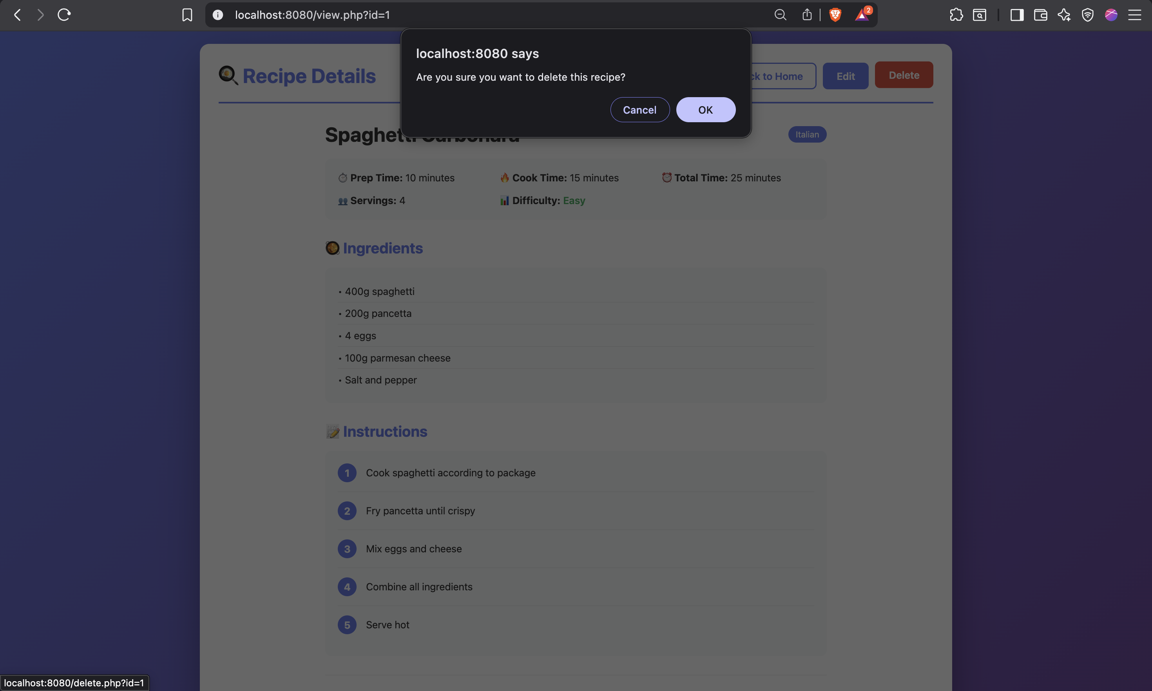

### 7.6 Search Functionality

Screenshot showing the multi-criteria search form with filters applied

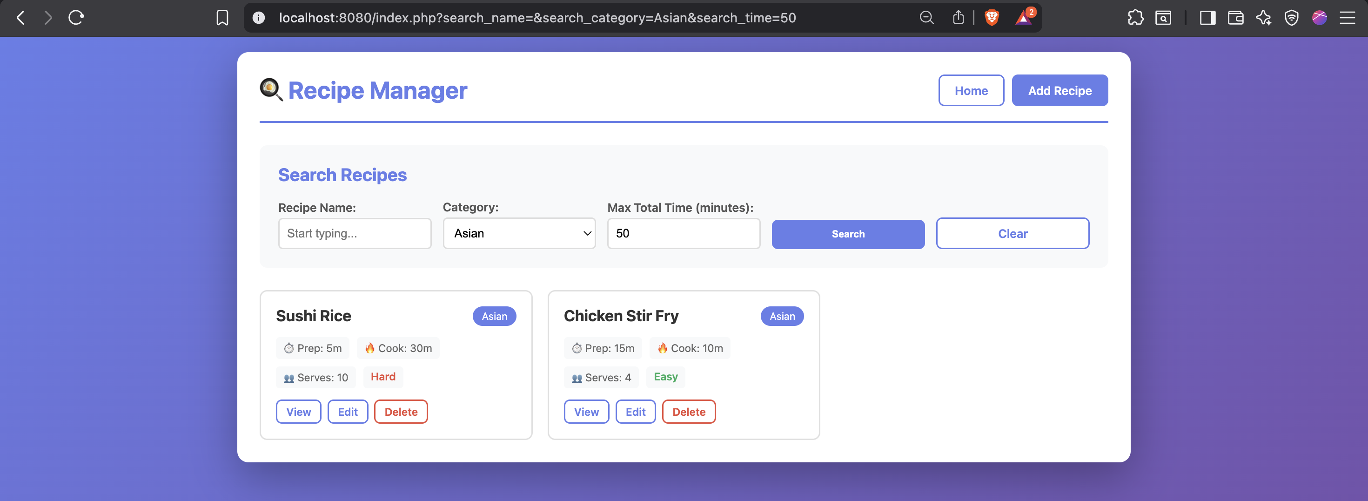

### 7.7 Autocomplete in Action

Screenshot showing the autocomplete dropdown with suggestions

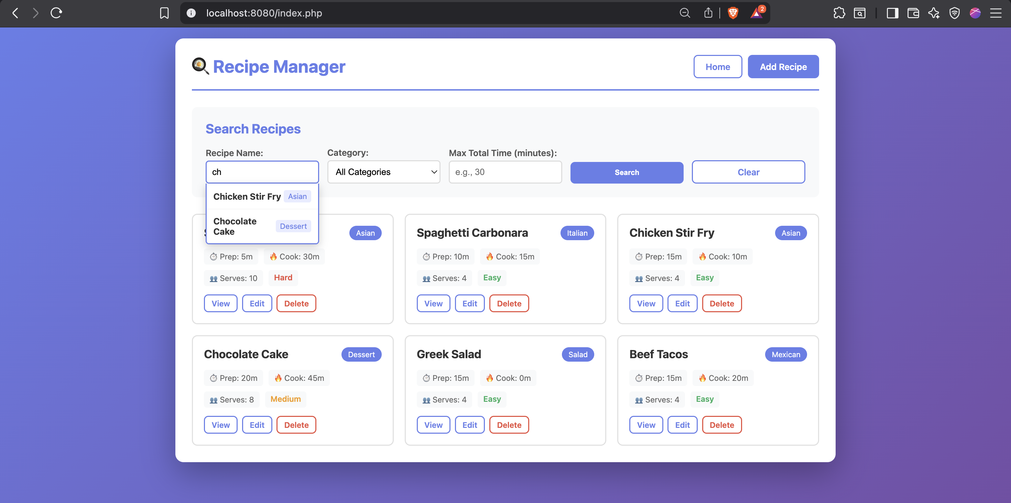

## 8. Conclusion

The Recipe Manager project successfully implements a fully functional web application with the following achievements:

Features Implemented

* Complete CRUD operations for recipe management
* Multi-criteria search functionality (name, category, time)
* Real-time Ajax autocomplete with debouncing
* Responsive and user-friendly interface
* Comprehensive security measures

Security Measures

* SQL injection protection via prepared statements
* XSS prevention through output escaping
* CSRF token validation for all forms
* Secure session configuration

Technical Skills Demonstrated

* Server-side programming with PHP
* Database design and MySQL queries
* Client-side JavaScript and Ajax
* Responsive web design with CSS3
* Web security best practices

## Project Files

| **File** | **Description** |
| --- | --- |
| index.php | Home page with recipe grid and search |
| add.php | Add new recipe form and processing |
| view.php | Display individual recipe details |
| edit.php | Edit existing recipe form and processing |
| delete.php | Delete recipe with confirmation |
| autocomplete.php | Ajax endpoint for search suggestions |
| config.php | Database configuration and security functions |
| script.js | JavaScript for autocomplete functionality |
| style.css | Application stylesheet |
| database.sql | Database schema and sample data |